|  |  |  |
| --- | --- | --- |
|  | Foundation Activity 6 Introduction to Soldering | |
| What is Soldering? | | Why Solder? |
| Soldering is the use of molten metal to make permanent electrical connections. | | * Reliable * Compact * Good Conductivity |

|  |  |  |
| --- | --- | --- |
| [1] | Solder | A soft metal that melts at a low temperature (usually a combination of lead and tin) |
|  | Soldering Iron | Used to melt the solder and heat the parts to be soldered |
| C:\Users\Harryp\MEGA\Surface Pro 2\Nepal\Himalayan Makers Guild\Activities\Activity 8 - Intro to Soldering\images\icons\png\flux.png | Flux | A paste/liquid that, when heated, helps the solder flow and bond to other metals |
| C:\Users\Harryp\MEGA\Surface Pro 2\Nepal\Himalayan Makers Guild\Activities\Activity 8 - Intro to Soldering\images\icons\png\sponge.png | Soldering Sponge | For cleaning the tip of the iron |

Safety

|  |  |  |
| --- | --- | --- |
|  | Wear safety glasses. |  |
| C:\Users\Harryp\MEGA\Surface Pro 2\Nepal\Himalayan Makers Guild\Activities\Activity 8 - Intro to Soldering\images\icons\png\wind.png | Work in a well ventilated area. |  |
| C:\Users\Harryp\MEGA\Surface Pro 2\Nepal\Himalayan Makers Guild\Activities\Activity 8 - Intro to Soldering\images\icons\png\flame.png | Only hold the soldering iron while soldering. Otherwise, put it in the soldering iron stand. |  |
| C:\Users\Harryp\MEGA\Surface Pro 2\Nepal\Himalayan Makers Guild\Activities\Activity 8 - Intro to Soldering\images\icons\png\003-hands.png | Wash your hands after soldering and do not touch your face while working with solder. |  |

How To Make a Wire-to-Wire Solder Joint

|  |  |
| --- | --- |
| C:\Users\Harryp\MEGA\Surface Pro 2\Nepal\Himalayan Makers Guild\Activities\Foundation Activities\FA6 - Intro to Soldering\images\wire-wire-joint.png | 1. Tin the soldering iron tip by melting solder on it, then wiping the extra solder off onto the sponge. This gives the solder tip good wetting. |
| 1. Touch the tip of the soldering iron to the joint so that it contacts both the wires. |
| 1. Apply the solder so that it touches the wires on the side opposite where the iron is touching. |
| 1. Remove the solder wire from the joint. (if you take away the iron first, the solder wire will stick to the joint!) |
| 1. Remove the soldering iron from the joint. |

Voltage Tester Circuit

Our objective is to solder together this LED circuit. It can be used to test for the (+) and (-) side of a voltage source that is greater than 3V. It should not be used for sources over 9V.

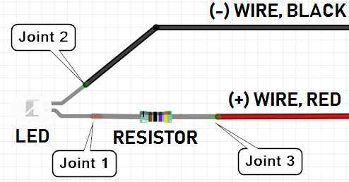[2]

1. Icons made by [Freepik](http://www.freepik.com) from [www.flaticon.com](https://www.flaticon.com/)
2. Circuit image made with Fritzing